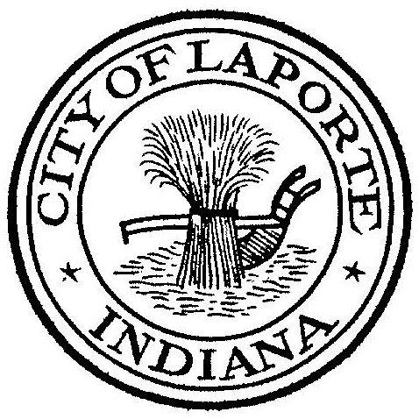
Board of Public Works and Safety
Jessica Romine, Member Tom Dermody, Mayor Mark Kosior, Member
City Hall 801 Michigan Ave., La Porte, IN 46350
Wednesday, January 4, 2023
9:00 AM
AGENDA
- Call To Order
- Pledge Of Allegiance
- Approval Of Minutes
- Public Comment: In Person and via Facebook Live
- Clerk-Treasurer: Claims Approval
- New Business:
-Nick Otis: Loniewski Annexation Agreement
-Nick Minich: Approval of Emergency Vehicle Preemption Final Tracing Plan Set
Approval on INDOT-LPA Contract for Des.No 2201435 (CCMG Paving Project
7) Unfinished Business:
8) Other Business: Next Meeting will be on Wednesday, January 18, 2023

